Nine different types of entrepreneurship

Here are the different types of entrepreneurship:

1. **Small business entrepreneurship**
2. **Large company entrepreneurship**
3. **Scalable startup entrepreneurship**
4. **Social entrepreneurship**
5. **Innovative entrepreneurship**
6. **Hustler entrepreneurship**
7. **Imitator entrepreneurship**
8. **Researcher entrepreneurship**
9. **Buyer entrepreneurship**

**Small business entrepreneurship**

A majority of businesses are small businesses. People interested in small business entrepreneurship are most likely to make a profit that supports their family and a modest lifestyle. They aren't seeking large-scale profits or venture capital funding. Small business entrepreneurship is often when a person owns and runs their own business. They typically hire local employees and family members. Local grocery stores, hairdressers, small boutiques, consultants and plumbers are a part of this category of entrepreneurship.

**Large company entrepreneurship**

Large company entrepreneurship is when a company has a finite amount of life cycles. This type of entrepreneurship is for an advanced professional who knows how to sustain innovation. They are often a part of a large team of C-level executives. Large companies often create new services and products based on consumer preferences to meet market demand. Small business entrepreneurship can turn into large company entrepreneurship when the company rapidly grows. This can also happen when a large company acquires them. Companies such as Microsoft, Google and Disney are examples of this kind of entrepreneurship.

**Scalable startup entrepreneurship**

This kind of entrepreneurship is when entrepreneurs believe that their company can change the world. They often receive funding from venture capitalists and hire specialized employees. Scalable startups look for things that are missing in the market and create solutions for them. Many of these types of businesses start in Silicon Valley and are technology-focused. They seek rapid expansion and big profit returns. Examples of scalable startups are Facebook, Instagram and Uber.

**Social entrepreneurship**

An entrepreneur who wants to solve social problems with their products and services is in this category of entrepreneurship. Their main goal is to make the world a better place. They don't work to make big profits or wealth. Instead, these kinds of entrepreneurs tend to start nonprofits or companies that dedicate themselves to working toward social good.

**Innovative entrepreneurship**

Innovative entrepreneurs are people who are constantly coming up with new ideas and inventions. They take these ideas and turn them into business ventures. They often aim to change the way people live for the better. Innovators tend to be very motivated and passionate people. They look for ways to make their products and services stand out from other things on the market. People like Steve Jobs and Bill Gates are examples of innovative entrepreneurs.

**Hustler entrepreneurship**

People who are willing to work hard and put in constant effort are considered hustler entrepreneurs. They often start small and work toward growing a bigger business with hard work rather than capital. Their aspirations are what motivates them, and they are willing to do what it takes to achieve their goals. They do not give up easily and are willing to experience challenges to get what they want. For example, someone who is a hustler is willing to cold call many people in order to make one sale.

**Imitator entrepreneurship**

Imitators are entrepreneurs who use others' business ideas as inspiration but work to improve them. They look to make certain products and services better and more profitable. An imitator is a combination between an innovator and a hustler. They are willing to think of new ideas and work hard, yet they start by copying others. People who are imitators have a lot of self-confidence and determination. They can learn from others' mistakes when making their own business.

**Researcher entrepreneurship**

Researchers take their time when starting their own business. They want to do as much research as possible before offering a product or service. They believe that with the right preparation and information, they have a higher chance of being successful. A researcher makes sure they understand every aspect of their business and have an in-depth understanding of what they are doing. They tend to rely on facts, data and logic rather than their intuition. Detailed business plans are important to them and minimize their chances of failure.

**Buyer entrepreneurship**

A buyer is a type of entrepreneur who uses their wealth to fuel their business ventures. Their specialty is to use their fortunes to buy businesses that they think will be successful. They identify promising businesses and look to acquire them. Then, they make any management or structural changes they feel are necessary. Their goal is to grow the businesses they acquire and expand their profits. This kind of entrepreneurship is less risky because they are purchasing already well-established companies.

**What are the three C's of entrepreneurship?**

The three C's of entrepreneurship are curiosity, connections and creating value.

Curiosity allows entrepreneurship to identify consumer problems when competitors are unable to or ineffectively address them.

Connections refer to the process of integrating existing knowledge with one's unique discoveries to develop comprehensive solutions.

Additionally, entrepreneurs create value for consumers by offering distinct products or services and adjusting their goods according to evolving preferences.

**What are the two main types of entrepreneurs?**

The two main types of entrepreneurs are business owners and angel investors. Business owners want to not only manage their companies but also have direct involvement in their creation. Angel investors typically have less control over a company's operations and focus on providing resources to generate positive financial returns.

**Why are there different types of entrepreneurs?**

Different types of entrepreneurs exist because people can pursue business ownership via different avenues. For instance, someone who has good business acumen might want to start their own business, even if they have limited funds. An individual with significant funds and little business expertise might find it more appropriate to become an angel investor. Aside from your means, your personality traits can also influence what type of entrepreneur you might become.

# **10 Benefits of Using Design Thinking for Innovation**

****The principles of design thinking**** can help you create products and services based on users’ needs. This approach comes with a series of advantages, allowing you to build solutions that convert users into loyal customers. So, in this article, we will explain the principles of design thinking. You will also learn the 10 benefits of applying design thinking methodologies to your upcoming projects to make user-centric products.

Table of Contents

* [What Do You Mean by the Principles of Design Thinking?](https://slash.co/articles/10-benefits-of-using-design-thinking-for-innovation/" \l "What_Do_You_Mean_by_the_Principles_of_Design_Thinking" \o "What Do You Mean by the Principles of Design Thinking?)
* [Principles of Design Thinking Explained](https://slash.co/articles/10-benefits-of-using-design-thinking-for-innovation/" \l "Principles_of_Design_Thinking_Explained" \o "Principles of Design Thinking Explained)
  + [1. Human-Centric Perspective](https://slash.co/articles/10-benefits-of-using-design-thinking-for-innovation/" \l "1_Human-Centric_Perspective" \o "1. Human-Centric Perspective)
  + [2. Ambiguity](https://slash.co/articles/10-benefits-of-using-design-thinking-for-innovation/" \l "2_Ambiguity" \o "2. Ambiguity )
  + [3. Re-design](https://slash.co/articles/10-benefits-of-using-design-thinking-for-innovation/" \l "3_Re-design" \o "3. Re-design)
  + [4. Tangibility](https://slash.co/articles/10-benefits-of-using-design-thinking-for-innovation/" \l "4_Tangibility" \o "4. Tangibility)
* [10 Benefits of Using the Principles of Design Thinking](https://slash.co/articles/10-benefits-of-using-design-thinking-for-innovation/" \l "10_Benefits_of_Using_the_Principles_of_Design_Thinking" \o "10 Benefits of Using the Principles of Design Thinking)
  + [1. Increased Innovation Output](https://slash.co/articles/10-benefits-of-using-design-thinking-for-innovation/" \l "1_Increased_Innovation_Output" \o "1. Increased Innovation Output)
  + [2. Improved Understanding of Customers](https://slash.co/articles/10-benefits-of-using-design-thinking-for-innovation/" \l "2_Improved_Understanding_of_Customers" \o "2. Improved Understanding of Customers)
  + [3. Elimination of Cognitive Fixedness](https://slash.co/articles/10-benefits-of-using-design-thinking-for-innovation/" \l "3_Elimination_of_Cognitive_Fixedness" \o "3. Elimination of Cognitive Fixedness)
  + [4. Enhanced Product Usability and Acceptance Rate](https://slash.co/articles/10-benefits-of-using-design-thinking-for-innovation/" \l "4_Enhanced_Product_Usability_and_Acceptance_Rate" \o "4. Enhanced Product Usability and Acceptance Rate)
  + [5. More Focused on Experimentation and Creativity](https://slash.co/articles/10-benefits-of-using-design-thinking-for-innovation/" \l "5_More_Focused_on_Experimentation_and_Creativity" \o "5. More Focused on Experimentation and Creativity)
  + [6. Offers Solutions to Customers’ Problems](https://slash.co/articles/10-benefits-of-using-design-thinking-for-innovation/" \l "6_Offers_Solutions_to_Customers%E2%80%99_Problems" \o "6. Offers Solutions to Customers’ Problems)
  + [7. Expanded Design Thinkers’ Vision](https://slash.co/articles/10-benefits-of-using-design-thinking-for-innovation/" \l "7_Expanded_Design_Thinkers%E2%80%99_Vision" \o "7. Expanded Design Thinkers’ Vision)
  + [8.  Overcoming Wicked Problems](https://slash.co/articles/10-benefits-of-using-design-thinking-for-innovation/" \l "8_Overcoming_Wicked_Problems" \o "8.  Overcoming Wicked Problems)
  + [9. Resource Cutdown](https://slash.co/articles/10-benefits-of-using-design-thinking-for-innovation/" \l "9_Resource_Cutdown" \o "9. Resource Cutdown)
  + [10. Leading Team Towards Tangible Results](https://slash.co/articles/10-benefits-of-using-design-thinking-for-innovation/" \l "10_Leading_Team_Towards_Tangible_Results" \o "10. Leading Team Towards Tangible Results)
* [Conclusion](https://slash.co/articles/10-benefits-of-using-design-thinking-for-innovation/" \l "Conclusion" \o "Conclusion)

## What Do You Mean by the Principles of Design Thinking?

Before knowing the principles of design thinking, let’s learn what the term “design thinking” means.

Design thinking is an iterative approach that enables design and development teams to focus on issues and take action to overcome them. Through the design thinking method, teams can build problem-solving products by working on prototypes after understanding what customers really want.

The design thinking framework helps determine and identify problems faced by customers. Design thinking prepares great design thinkers with an enhanced vision to understand consumers’ needs. They look at a product through users’ engagement rather than from the company’s perspective or assumption of customer interaction.

Many [design thinking examples](https://medium.com/voltage-control/8-great-design-thinking-examples-a01d6d0debbe" \t "https://slash.co/articles/10-benefits-of-using-design-thinking-for-innovation/_blank) verify how important it is to have a product backed by design thinkers. Likewise, there are several great [design thinking books](https://medium.com/the-pm-library/7-top-books-for-design-thinkers-78d9b91450ac" \t "https://slash.co/articles/10-benefits-of-using-design-thinking-for-innovation/_blank) you can read to increase your knowledge.

## Principles of Design Thinking Explained

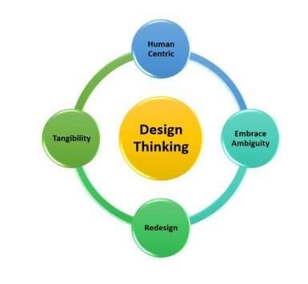

Larry Leifer and Christoph Meinel from the Hasso-Plattner Institute of Design proposed four principles of design thinking:

### 1. Human-Centric Perspective

The first rule is that in order to solve technical problems, you must always consider the human-centric approach.

### 2. Ambiguity

If needed, designers must think independently and creatively to find new and improved solutions.

### 3. Re-design

Design thinkers must learn how technology has benefited human needs in the past. At the same time, they must learn to understand these methods to satisfy user demands in the future.

### 4. Tangibility

Prototyping is the ideal way to gain knowledge of how a new product can fulfill customers’ needs. This rule insists on continuous experimentation, creative criticism, and discussion until the solution is found.

## 10 Benefits of Using the Principles of Design Thinking

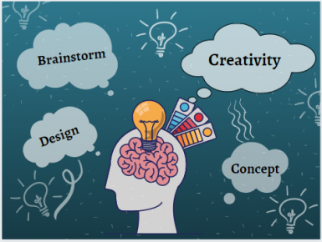

### 1. Increased Innovation Output

The design thinking process is user-centric that allows you to build innovative solutions. Therefore, the principles of design thinking give you the ability to create products that add value to your users’ lives. This not only permits you to have happy customers but also experience improved revenue, increased sales, and referral rates. Through design thinking, you can also iterate on your existing products and improve them to meet your customers’ needs.

### 2. Improved Understanding of Customers

The principles of design thinking compel you to understand your customer’s behavior deeply. That includes knowing their daily habits, fears, pain points, and motivation, allowing you to have empathy for those who will use your product. As a result, you can create innovative products that actually cater to your customers’ demands.

The design thinking tools like exploratory research and interviews not only benefits the design team but also supports other business departments, including:

* Sales
* Marketing
* Customer services

### 3. Elimination of Cognitive Fixedness

Cognitive fixedness is a state of mind that consciously or unconsciously creates an interpretation of a given situation. Think of a time when you thought you couldn’t build a SaaS product because the model was too complex. So you gave up on it rather than finding ways to defeat hurdles.

Well, the principles of design thinking help you overcome cognitive fixedness. You get a new and more rational perspective to see your product. Likewise, it lets you explore more creative and much better ways to find solutions instead of following traditional methods.

### 4. Enhanced Product Usability and Acceptance Rate

One of the benefits of design thinking is increased product usability. Remember, the principles of design thinking encourage building programs through empathy. Therefore, it enables you to build products that customers love to use. And since you hit the core needs through your product, it automatically attracts more users and converts prospects.

### 5. More Focused on Experimentation and Creativity

The principles of design thinking revolve around design, testing, and iteration. When these three factors are combined, they allow you to build winning products. Why so? It is because the design thinking approach helps you create numerous prototypes in a minimum time period.

You are able to receive fast feedback from real users and continue experimenting until the solution matches users’ demands. Moreover, design thinking also helps you decide what features to add, exclude, or modify in your current idea to make it more user-centric.

### 6. Offers Solutions to Customers’ Problems

The design thinking process is human-centered. In other words, it permits you to identify and solve problems for all industries at all levels. At the same time, design thinking principles help your business provide a way out of the most challenging obstacles once they are discovered.

### 7. Expanded Design Thinkers’ Vision

Assuming to build a problem-solving product without design thinkers on your side, no way! Design thinkers are people who are exposed to a wide range of problems and know possible solutions. So what makes them so hawkeyed? It is the knowledge of the principles of design thinking.

These principles allow them to visualize situations through an observational approach, letting them know what consumers look for in products. In fact, they can see solutions which may not be visible even to users.

### 8.  Overcoming Wicked Problems

A “wicked problem” refers to a situation where teams cannot clearly point out issues that prevent them from proposing a way out. It slows the product-building process and kills time. So, if you come across this big rock, you can use the principles of design thinking to climb over it. Indeed, design thinking removes the veil from the missing puzzles and permits you to find possible solutions through constant testing.

### 9. Resource Cutdown

Design thinking streamlines the entire innovation process. It makes your daily operations more efficient and purposeful. Mistakes and failures are expected during product iteration and idea testing, but design thinking principles give you actionable next steps. Thus, allowing you to save time and money as you don’t repeat the development cycle from the initial phase.

### 10. Leading Team Towards Tangible Results

Paired with high technical expertise, the principles of design thinking enable teams to build successful products. When you adopt design thinking for team building, it empowers teams to create products which **ensure user retention and fruitful results**.

## Conclusion

The principles of design thinking permit teams to use their maximum creativity to develop problem-solving products. While the design thinking process helps you build innovative and engaging solutions, it also saves time and effort. Moreover, it increases your capability of exploring and including features that customers admire to use—correspondingly giving a competitive edge to your business.

[Slash](https://slash.co/product-development/) is packed with design thinkers. We have design thinking principles in the air, and our squad breathes it. With the combination of agile methodologies and a design thinking framework, we assure you of creating conquering solutions that your customers love. [Talk to us](https://slash.co/pricing/product-design/) to hire a top-class team of talented software designers and engineers.

## **EFFECTUATION – THE BEST THEORY OF ENTREPRENEURSHIP YOU ACTUALLY FOLLOW, WHETHER YOU’VE HEARD OF IT OR NOT**

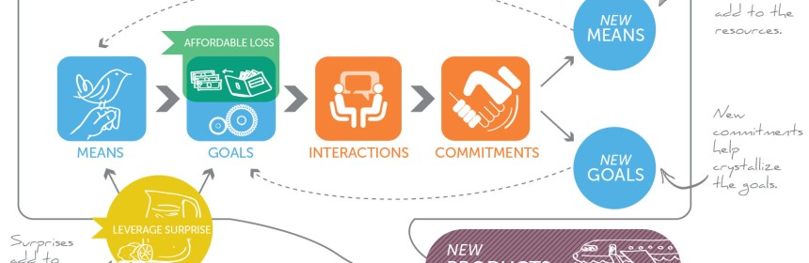

University of Virginia Darden professor Saras Sarasvathy’s groundbreaking 2001 paper “What Makes Entrepreneurs Entrepreneurial” finally gained some widespread recognition when [Vinod Khosla](http://www.khoslaventures.com/presentations/What_makes_entrepreneurs_entrepreneurial.pdf) posted a copy on his website with some personal notes, one of which read: “First good paper I’ve seen”.

Professor Sarasvathy developed the [Effectuation](http://www.effectuation.org/) theory of entrepreneurship after exhaustively interviewing 27 serial entrepreneurs.  Her research findings greatly advanced the answer to the age-old-question – **What do entrepreneurs actually do?** (thus defining the process of entrepreneurship, which everyone seems to viscerally believe it is different from management).

Effectuation is generally defined as a form of reasoning or problem solving which assumes the future is largely unpredictable, but that it can be controlled through human action.   This is in stark contrast to another form of reasoning, Causality, which assumes the future is theoretically predictable based on prior events.

Sarasvathy argues casual thinkers start with an End in mind and try to find the best Means to achieve it – They follow the adage “”If I can predict the future, I can control it.”

Sarasvathy observed that most managers are Causal thinkers, but not entrepreneurs (for the most part).   She observed that entrepreneurs are indeed Effectual thinkers who start with a given set of Means and find new and different Ends, which are not necessarily pre-determined.  Entrepreneurs in her studies follow the adage “If I can control the future, I do not need to predict it”.

[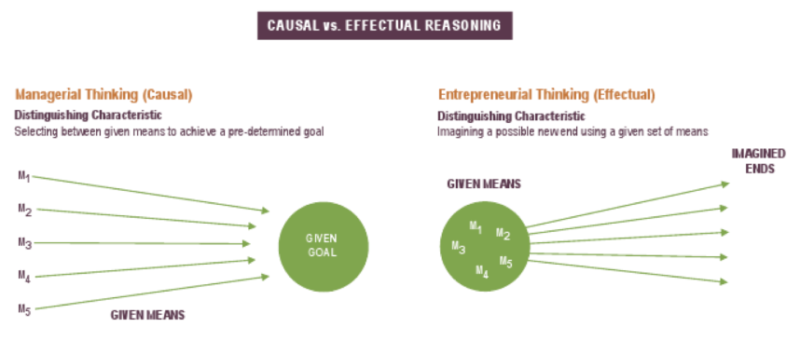](https://necrophonedotcom.files.wordpress.com/2014/01/effectual-vs-casual-thinking.png)

Professor Sarasvathy meticulously researched and proved what a lot of us have felt at heart – ****Entrepreneurs make it up as they go along – and that this process can be learned!****  This is refreshing as previous theories of entrepreneurship weren’t exactly inclusive or practical, emphasizing ‘special’, risk-taking traits that only some people would innately possess or theoretical market imbalances and radical technologies that created opportunities for disruption (that most of us wouldn’t be able to recognize, much less base our plans for world domination).

****The brilliant principles of effectuation****

The theory of effectuation boils down to the observation that when it comes to Entrepreneurship, Effect trumps the Casual view of the world (that the future is neither found nor predicted, but made – so focus on what you can control).  The theory of effectuation is further complemented by four basic principles derived from Professor Saravathy’s original study:

****Bird in Hand Principle – Start with your means****  
Entrepreneurs start with what they have:  Who they are, what they know and who they know – For example, if a cook were to act entrepreneurially, he or she would concoct an unknown dish with whatever ingredients were available in the kitchen pantry, not follow a known recipe (nor necessarily a vision).  The bird in hand principle or “making do with resources at hand” was first introduced by Levi-Strauss in 1967 specifically in the context of Arts, Crafts and Science and has since been carried to the field of entrepreneurship by a slew of other scholars and practitioners.  This principle essentially says ‘Just Start!’, instead of waiting for the perfect conditions to arrive (which is not the same as advising to ‘Just Do It!’, meaning to faithfully following your gut towards an inflexible end goal without a care for proof along the way).

****Affordable Loss Principle – Set affordable loss****  
Traditional analysis of markets start with estimating the upside, the proverbial market sizing exercise (TAM, SAM, SOM, bla, bla).  But entrepreneurs usually pursue unknown markets.  Clayton Christensen said it best “unknown markets cannot be analyzed”.  Turns out entrepreneurs are more concerned with analyzing the down-side of their actions to manage their risk, which can often be accurately calculated – If they can afford the cost (of an experiment), they jump into the venture and if they can’t, they choose something else they can afford.  This is also the basis for the VC industry (staged risk), although they still make prospective portfolio companies provide ridiculous spreadsheet projections, maybe so they can have a good laugh when people leave the room – those masochists!

****Lemonade Principle – Leverage contingencies****  
The Lemonade Principle is my favorite (I know, I don’t get out enough if I have favorite principles from a relatively obscure theory).  Obviously inspired by the aphorism “If life deals you lemons, make lemonade” (I presume life also gives you the sugar, but I digress), this principle basically states that entrepreneurs must be flexible above all else, not recalcitrant – ****that entrepreneurs must expect to exploit the unexpected, not existing knowledge.****

The way this principle is stated also emphasizes the upside of being flexible or open to change, not simply the notion that flexibility is primarily designed to avoid failure – flexibility is also the best way to fight complacency – to constantly seek something better (play offense, not simply defense).   The Lean Startup movement has unfortunately taken on the meaning of an effective philosophy to ‘avoid failure’ – “When are things going so wrong that one needs to pivot?” – Is often the question asked vs. “How do we know when we’ve exhausted the upside of this beautiful thing called a strategic [pivot](https://necrophone.com/2013/11/20/lean-startups-trivia-2/" \o "Lean Startups Trivia 2) and should finally focus on the current direction?”.   Innovation in general, for that matter, is usually brought about in a negative, “innovate or die” dictum vs. “***Who cares about your eroding competitive advantages or threat of disruption – The world needs additional sources of human happiness – so please get out there an innovate more!”***

****Crazy-Quilt Principle – Form partnerships****  
I have no idea why this principle is called the crazy-quilt principle, but it sounds pretty cool.  This principle basically encourages entrepreneurs to be networking machines – period.  You never know what may come of talking to customers, experts and other companies – a much better use of time than insipid market research or planning exercises based on competitive paranoia (****as a startup, you’re an ant – you have no competitors****).   Partnerships can fuel a given business model design as well as provide inspiration for a new business model altogether (they can create new means to new ends).   Partnerships (and key commitments, of course) can also provide the missing proof of business-model scalability that gains the confidence of investors.  Market making, industry-control issues are certainly important in the growth of a startup (so careful with partnering terms), but avoiding contact in the early stages has never been proven as a formula for toughness and resilience.  Just like in international affairs, alliances trump isolationism (sorry North Korea).

****Summary****

* Effectuation is a valuable theory based on solid field research to explain what entrepreneurs actually do
* It complements other theories of entrepreneurship such as Lean Startups and Bricolage that recognize the uncertainty of venturing into unknown markets vs. the certainty of executing in known markets
* In its advice on how we can reduce uncertainty, Effectuation is practical, sensible, inspiring and inclusive – Just start with what you have, risk what you can afford, be open to pleasant surprises, and seek relationships with others

# Customer Segmentation Models: Types, Benefits & Uses

No two customers are exactly alike. And what your brand does can serve a wide variety of people - which is good for business, but a major marketing challenge. How do you market yourself to so many disparate consumers?

You could take a scattershot approach, throwing everything at the wall and hoping something sticks. Or you could create a laser-focused strategy - one that tailors your marketing efforts to the needs and interests of specific groups of customers. One that segments customers.

Customer segmentation uses different methods, or models, to divide your customers into smaller subgroups defined by shared characteristics. These common characteristics help you create customer profiles, and these in turn lead to increasingly personalized marketing messages that guide customers through their buyers journey.

Understanding your customers is key to the success of your business and customer segmentation is a crucial part of that understanding. Let’s take a closer look at customer segmentation models and how to choose the right ones for your brand.

## ****What is a Customer Segmentation Model?****

A customer segmentation model is a way of dividing a wide group of people into smaller groups based on their commonalities. How you divide your larger customer base into those smaller subgroups will vary based on what your brand does and who your customers generally are. If you’re a business-to-business brand providing accounting services to small and medium-sized businesses, one of your segmentation models may focus on the different industries in which your customers’ businesses operate. You would be using an industry-specific segmentation model. For a business-to-consumer brand, your customer segmentation models may focus on shared demographics like age, gender, and income level. How you divide your customer base varies on the characteristics you want to target with more personalized messaging.

## ****What Are the Benefits of a Customer Segmentation Model?****

Customer segmentation models allow you to create increasingly specific marketing messages tailored to the right person at the right leg of their customer journey. Not only does this build brand trust – by creating the feeling that you understand your customers, their interests, and concerns – it also improves your overall ROI by reducing waste in advertising.

Why waste time on guesswork when a segmentation strategy based on the right-for-you model lets you target exactly who needs what and when?

**Further benefits of finding the right customer segmentation model include:**

* ****Increase consumer engagement.****Targeted ads and marketing messages connect the right-fit potential consumers to your brand and encourage continued engagement from existing consumers.
* ****Increase consumer satisfaction and loyalty.****The customer that feels seen, heard, and understood by a brand is going to be far more satisfied, and loyal, than the one who feels like they’re just an order number.
* ****Improve ROI.**** Customer segmentation eliminates wasted time, and therefore money, on marketing efforts that don’t target the right audience. When you understand your consumers and what they need, you can help them fill that need faster and more efficiently.

## ****What are the Types of Customer Segmentation Models?****

****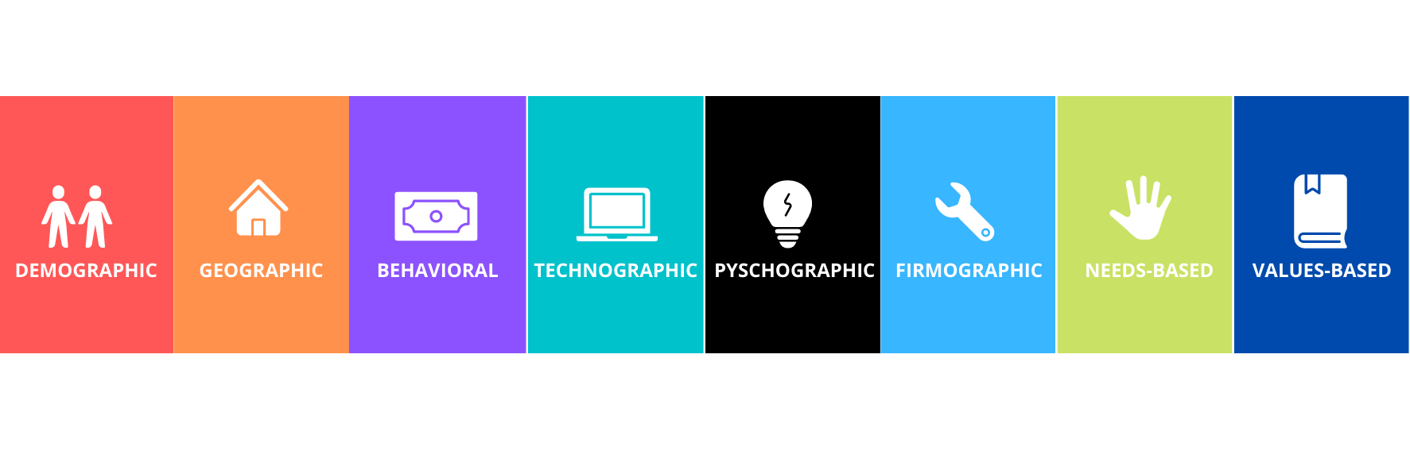****

Successful customer segmentation is not a one size fits all approach. There are a number of different models to explore:

### ****Demographic Segmentation****

Demographics are population-related characteristics such as income, education level, gender, and age. The various demographic characteristics can be used together to create segmented customer groups, most useful to brands that sell a variety of products.

For example, a company that sells both mid-range and luxury bath products for women and men may segment their customers by gender as well as income. This way they can create ads that target women with an annual income of $150,000 and separate ads for men with an annual income of $70,000.

### ****Behavioral Segmentation****

Behavioral segmentation groups consumers together by habits and behaviors, rather than external demographic factors. For example, purchase history and preferred social media platform usage. You can focus ads on a certain social platform to reach and/or create reminder or sales emails to regular or repeat online buyers.

### ****Psychographic Segmentation****

Psychographic segmentation dives even deeper into the internal workings of your consumers by grouping them together based on psychological characteristics, including personality, habits, beliefs, and interests.

Psychographics are great for lifestyle brands that want to align themselves with consumers who live or aspire to live the lifestyle that the brand promotes. Brands that sell outdoor camping gear, for example, want to connect with outdoor and travel enthusiasts.

### ****Geographic Segmentation****

Geographic location is important to brands in a number of industries. Real estate agencies, for example, want to connect with homeowners selling their homes, potential buyers, and people looking to relocate to a specific area.

Other businesses may sell products tailored to people living in particular climates. Understanding the needs and challenges of consumers living in different locations is a core element of successfully marketing your products or services in those locales.

### ****Technographic Segmentation****

Technographic segmentation, or creating subgroups and customer profiles around the technology your consumers use, is becoming increasingly popular. As more businesses have moved their operations online, this has opened the door to growth in industries like SaaS and online marketing analytics.

Technographic segmentation lets you target consumers that use different types of software or online services in a highly personalized fashion.

### ****Firmographic Segmentation****

Millennials vs. Gen X’ers vs. Gen Z vs. Boomers – we’re becoming more and more comfortable with the idea of these generational divides. So much so that firmographic segmentation, or creating subgroups simply around the decades or eras into which your consumers were born, is also on the rise.

And it makes sense – someone born in 1980 will be at a different stage of life, with different needs and concerns, than someone born in 2000.

### ****Needs-Based Segmentation****

Needs-based segmentation begins with a simple question: Who needs what you’ve got?

Dividing your consumers into groups around their needs is a great way to keep your marketing messages focused tightly on your products or services and how they meet those needs. A clothing company can market office casual wear to business professionals, athletic gear to yoga enthusiasts, and kids' clothing to families.

### ****Value-Based Segmentation****

This model takes the lens and focuses it more directly on what serves your brand. Which group or groups of customers are currently providing the most value – the most return business, the highest return on your ROI?

Using lifetime value as your measuring stick, you can target your marketing messages to the consumers that are your biggest supporters and focus on continuing to build that loyalty and trust.

## ****5 Questions to Ask to Find the Right Segmentation Model for Your Business****

Customer segmentation isn’t a one-and-done thing. It takes a fair amount of trial and error to dial into the segmented groups that provide you with the most value, insight, and ROI. Don’t be afraid to explore a variety of models or to get into the habit of reassessing the models you currently use to create your customer segmentation strategy.

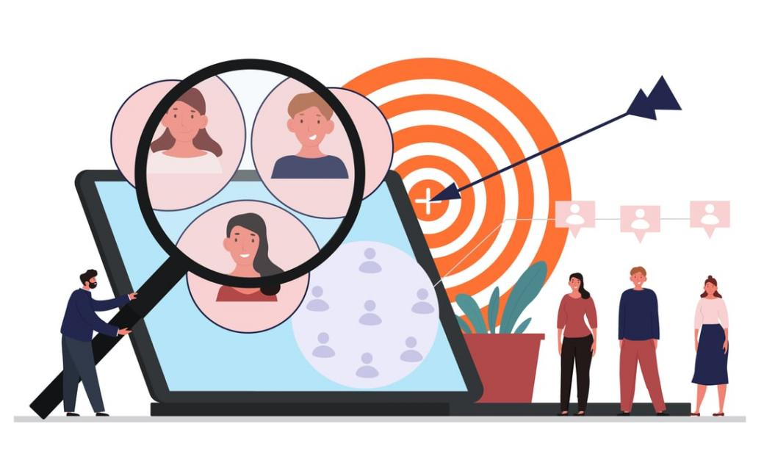

To help you choose which model or models work best for you, answer these questions:

### ****1. What is your immediate goal?****

Whether your goal is to launch a new product or service, raise your rate of returning customers or simply improve your overall sales, having a specific marketing goal in mind is the first step to refining your customer segmentation and choosing the right-for-you, right-for-now customer segmentation model.

### ****2. What’s the largest segment that will help you reach that goal?****

If your goal is to sell more of a specific product, ask yourself who is most likely to need – and therefore purchase – that product? Don’t worry if you get a very broad answer to this question.

This is the initial step of taking a large group of consumers and beginning to divide it into smaller segments. If your goal is to sell more hiking boots, “hikers” is the perfect place to start.

### ****3. Who makes up that broad segment?****

Breaking that larger segment down into smaller subgroups involves understanding the general characteristics of that group. To continue the hiking boot analogy - who buys hiking boots? Can you break that answer down by age, income, personality, geographic location, or something else?

Chances are you’ll have more than one answer. Hiking enthusiasts can be found in a number of different segments, such as demographic, psychographic, and geographic.

### ****4. What is the best segmentation model for your goal?****

Keep your goal in mind when diving deeper into the wants and needs of your larger segmented group. For the goal of selling more hiking boots, further defining what kind of boots you want to sell will help you get closer to that target segment.

If the boots you want to sell are made for steep and rocky terrain, targeting experienced long-distance hikers and backpackers makes more sense than aiming for casual trail goers.

In that case, you may choose a psychographic segmentation model, creating targeted ads and marketing that focus on the technical specs of your shoes, and how they’re built for the high stress a hardcore hiker will put them through.

### ****5. Do you have the right tools to understand your consumers, and evaluate the success of your segmentation model?****

The right [data analytics tools](https://www.marketingevolution.com/problems-we-solve/marketing-measurement-0?hsLang=en) are more important than ever. With so much of your marketing happening online, you need to evaluate your efforts across multiple platforms – and combine this data with that from your efforts offline as well.

Once you choose which customer segmentation model you want to use, you need to get the clearest, most up-to-date image possible in order to understand how well that model is working moving forward.

## ****Customer Segmentation Models in Action****

Customer segmentation models are used across industries and business types, and each model offers its own unique approach to understanding and targeting different subgroups of consumers.

Using real estate as our focus, let’s look at how three different models are each used to successfully target a business’ ideal consumer:

### ****Psychographic: Homesteaders****

For real estate agencies, connecting with the right homebuyer is crucial. Using psychographic segmentation, agents can connect, for example, with prospective homebuyers interested in homesteading by featuring properties that are further out in the country, offer a few clear acres, and are zoned for agriculture.

If an agency has a lot of these types of properties available, understanding the psychographics of various segmented groups will help that agency zero in on the right people to market those properties too.

### ****Geographic: Rural vs. Urban vs. In Between****

Real estate agencies are pros at marketing their properties to homebuyers interested in geographically-specific areas. If you’ve ever browsed through a real estate website or print listing you’re probably familiar with terms like “rural retreat,” “downtown nightlife” and “best of both worlds.”

Agencies understand the importance of geographic location and make a point of acenting the rural, urban, or suburban locales of their listing. Connecting prospective buyers with a beautiful property, just for those house hunters to find out it’s in a location they don’t want, is a quick way to lose a sale.

### ****Demographic: Mansion on the Hill****

The goal of marketing high-end properties lends itself well to demographic segmentation. Demographics, after all, help you segment customers into groups like age and income level.

Big, luxurious properties with an equally big price tag are pointless to market to customer segments in lower-income brackets, or below a certain age. Most 20 to 25-year-olds don’t have a few million dollars to spend on a property.

Creating a segment that focuses tightly on who has the wherewithal and the inclination to buy high-end allows real estate agencies to close sales quickly.

## ****Getting Started with Customer Segmentation****

Customer segmentation is an important part of your overall marketing and advertising strategy. The right message needs to find the right person at the right time along the buyer's journey. Not only does this increase your marketing ROI, and your sales, but it also builds a sense of trust and loyalty around your brand.

With so much of today’s marketing taking place online, creating clear customer profiles based on different segmentation models can be a challenge. You have a lot of data to sort through and make sense of.

**Marketing Evolution provides the**[performance measurement](https://www.marketingevolution.com/problems-we-solve/marketing-measurement-0?hsLang=en)**and**[media planning tools](https://www.marketingevolution.com/problems-we-solve/media-planning?hsLang=en)**you need to understand your customers’ journey and individual segment behaviors. Optimize your ROI and your segmentation strategy with key insights into your customers’ demographics, psychographics, and more.**

**Market types in entrepreneurship**

There are five main types of markets: consumer, business, institutional, government and global. Consumer markets offer freedom over product design and have a large and diverse customer base.

# **What is the Value Proposition Canvas?**

[](https://businessmodelanalyst.com/value-proposition-canvas/)

****Value Proposition Canvas**** is a [business model](https://businessmodelanalyst.com/business-model/) tool that helps you make sure that a company’s product or service is positioned around customers’ values and needs. The tool has been created by [Alexander Osterwalder](https://businessmodelanalyst.com/alexander-osterwalder/), Yves Pigneur, and Alan Smith. The same authors of the [Business Model Canvas](https://businessmodelanalyst.com/business-model-canvas/), aiming to map the value perceived by customers. The primary purpose is, therefore, to create a fit between the product and market. For this to happen, the Value Proposition Canvas explores more deeply these two (out of the nine) blocks from the Business Model Canvas: [Customer Segment](https://businessmodelanalyst.com/customer-segments-business-model-canvas/) and [Value Proposition](https://businessmodelanalyst.com/value-proposition-business-model-canvas/).

* [What are the advantages of using the Value Proposition Canvas?](https://businessmodelanalyst.com/value-proposition-canvas/" \l "What_are_the_advantages_of_using_the_Value_Proposition_Canvas" \o "What are the advantages of using the Value Proposition Canvas?)
* [What is Value Proposition Canvas like?](https://businessmodelanalyst.com/value-proposition-canvas/" \l "What_is_Value_Proposition_Canvas_like" \o "What is Value Proposition Canvas like?)
* [Client Profile](https://businessmodelanalyst.com/value-proposition-canvas/" \l "Client_Profile" \o "Client Profile)
  + [Jobs-to-be-done](https://businessmodelanalyst.com/value-proposition-canvas/" \l "Jobs-to-be-done" \o "Jobs-to-be-done)
  + [Pains](https://businessmodelanalyst.com/value-proposition-canvas/" \l "Pains" \o "Pains)
  + [Gains](https://businessmodelanalyst.com/value-proposition-canvas/" \l "Gains" \o "Gains)
* [Value Proposition](https://businessmodelanalyst.com/value-proposition-canvas/" \l "Value_Proposition" \o "Value Proposition)
  + [Products & Services](https://businessmodelanalyst.com/value-proposition-canvas/" \l "Products_Services" \o "Products & Services)
  + [Gain Creators](https://businessmodelanalyst.com/value-proposition-canvas/" \l "Gain_Creators" \o "Gain Creators)
  + [Pain Relievers](https://businessmodelanalyst.com/value-proposition-canvas/" \l "Pain_Relievers" \o "Pain Relievers)
* [When to use Value Proposition Canvas?](https://businessmodelanalyst.com/value-proposition-canvas/" \l "When_to_use_Value_Proposition_Canvas" \o "When to use Value Proposition Canvas?)
  + [Check out our Premium Value-Proposition Powerpoint Template:](https://businessmodelanalyst.com/value-proposition-canvas/" \l "Check_out_our_Premium_Value-Proposition_Powerpoint_Template" \o "Check out our Premium Value-Proposition Powerpoint Template:)

## **What are the advantages of using the Value Proposition Canvas?**

* Understanding the customer, with their needs and expectations;
* Developing a product in accordance with what your customer need and want;
* Comparing a product you already have with the user’s need;
* Finding your product-market fit;
* Avoiding producing something nobody wants,
* Saving time and money.

## **What is Value Proposition Canvas like?**



As said before, Value Proposition Canvas is made up of only two blocks – Value Proposition and Customer Segment. They are the core of the business model because they focus on “What” and “To whom”. In other words, how your company delivers value to your audience. The canvas is divided into two sides: on the right side, it’s the Client Profile. And that is divided into Jobs-to-be-done, Pains, and Gains. On the left side, it’s the Value Proposition, also subdivided into three: Products & Services, Gain Creators, and Pain Relievers. Let’s check each one out:

## **Client Profile**

### ****Jobs-to-be-done****



This is about what your customer is trying to do. You have to include all tasks customers are trying to perform, the problems they are trying to solve, and the needs they want to satisfy. It’s also important to note down the frequency and the importance of each job, and all the different roles the customer have to play, and in what contexts. To fulfill this step, you may ask yourself:

* What functional tasks is my customer trying to perform? (day by day tasks, problems at work, etc.)
* What social tasks is my customer trying to accomplish? (get a promotion, gain status, have a network, etc.)
* What emotional tasks is my customer trying to complete? (get in shape, feel good, feel motivated, etc.).
* What basic needs do they need/want to have satisfied? (communication, sex, hygiene, etc.).

### ****Pains****



This one encompasses everything that annoys your customer while they are performing their jobs-to-be-done, such as negative experiences and emotions, challenges, risks involved, financial costs, mistakes, and consequences, etc. Remember to classify each pain as severe or light and note down how often it takes place as well. To complete this step, you can make some questions:

* What is expensive for my customer? (regarding time, cost, effort, etc.)
* What makes my customer feel bad? (frustrations, disappointments, failures, physical pain, etc.)
* What are the main difficulties and challenges of my customer’s faces? (physical, intellectual or emotional limitations to do something, resistance, understanding certain situations, etc.)
* How current solutions are leaving to be desired for my customer? (bad performance, much effort, lack of functionality, defects, etc.)
* What are the negative consequences for my customer? (losses of power, status, money, time, trust, etc.)
* What risks is my customer afraid of? (financial, social, technical, etc.)
* What is keeping my customer awake at night? (concerns, challenges, debts, bad health, etc.)
* What are the most common mistakes my customer makes? (creating expectations, misunderstandings, errors in use, etc.)
* What is preventing my customer from adopting solutions? (investment, learning curve, resistance to changes, etc.)

### ****Gains****



They are all the benefits your customer expects or wishes – or even something that would surprise them positively –, whether they are functional, emotional, social or financial. In short, everything that delight them and make their life easier, more joyful or more successful. You may rank each gain by relevance and indicate the frequency of them. To do so, you can follow some questions, such as:

* What kinds of savings would make my customer happy? (time, money, energy, etc.)
* What results do my customer expect? Which ones can mesmerize them? (quality level, profits and gains, savings and improvements, etc.)
* What current solutions enchant my customer? (functionalities, performance, quality, etc.)
* What can make my customer’s tasks easier? (lower learning curve, more services, lower costs, etc.)
* What positive consequences do my customers want? (power, status, acknowledgment, satisfaction, motivation, etc.)
* What is my customer looking for? (design, guarantees, specific features, functionality, etc.)
* How does my customer measure success and failure? (cost, performance, speed, quality, beauty, likes on social networks, etc.)
* What would increase my customer’s chances of adopting a solution? (lower investment, longer guarantee, better performance/quality/design, etc.)

It’s worth remembering that you must create one profile for each customer segment. After mapping your customers’ profiles, the next step is to set what value they are going to perceive with your product or service.

## **Value Proposition**

### ****Products & Services****



Include all the products and services you are going to deliver. About each one, ask yourself:

* Can the product/service help to accomplish any job-to-be-done, whether functional, social, emotional, needs, wishes, roles, etc.?
* Is the product/service tangible, digital/virtual, or financial?
* Is the product/service crucial or trivial? How relevant is it?
* How often is the product/service used by my customer?

### ****Gain Creators****



Involve how the product/service offers the customer added value, what are the benefits your product brings, and if your customer’s wishes and expectations are reached. After all, how it makes your customer happier. Again, you should rank every gain your product or service creates according to relevance to your customers (if substantial or insignificant) and indicate how often it occurs. To do that, ask if your product/service:

* creates savings that make your customer happy (in terms of time, money, effort, etc.);
* produces results that your customer expects or that goes beyond their expectations (better level of quality, more of something, less of another);
* copies or does better than current offerings that delight your customer (in relation to specific functionalities, performance, quality, etc.);
* makes your customer’s tasks or life easier (lower learning curve, better usability, accessibility, more built-in services, lower cost of ownership, etc.);
* creates positive social consequences desired by your customer (make it look good on tape, produce or increase power, status, etc.);
* does/has something the customer is looking for (good design, specific or better functionalities, etc.);
* meets customers dreams (help on large goals, produce great relief, etc.);
* produces positive results that match criteria of success or failure (better performance, lower cost, etc.);
* makes adoption easier (reduce cost, lower investment, lower risk, higher quality, performance or design, etc.).

### ****Pain Relievers****



Describe how your product/service relieves the customer’s pains. Identify if you reduce their costs, negative feelings, efforts, risks, negative consequences, mistakes… Anyway, how you make your customer feel and sleep better. It’s important, also, to rank each pain, according to its intensity, to be able to understand how deeply your product/service help your customer. To help you out, ask if your product/service:

* produces savings (in terms of time, money, effort, etc.);
* makes your customer feel better (they end up with frustrations, discomforts, things that give headaches, etc.);
* performances solutions (new features, better performance, better quality, etc.);
* puts an end to the difficulties and challenges your customer faces (make things easier, help accomplish tasks, eliminate resistance, etc.);
* eliminates social consequences that your customer encounters or is afraid of (losses of respect, admiration, power, confidence, status, etc.);
* eliminates risks that your customer is afraid of (financial, social, technical risks, or anything else that can go very wrong);
* helps your customer sleep better at night (help with major problems, reduce worries, etc.);
* limits or eradicates common mistakes that your customer makes (errors of use, difficulties of use, etc.)
* eliminates barriers that prevent your customer from adopting new solutions.

## **When to use Value Proposition Canvas?**



In few words, this tool comes to facilitate the job of putting yourself in your customers’ shoes and understanding their world. The final goal, as mentioned above, is to discover your [Product Market Fit](https://businessmodelanalyst.com/downloads/product-market-fit-canvas-template/), through positioning products/services according to the necessities, expectations, and interests of your targeted customer. With Value Proposition Canvas, you have an overview of how your value proposition is going to impact your customer’s life. The product-market fit is achieved when the products and services match most the most important gains and pains of the customer profile. Usually, the Value Proposition Canvas works properly:

* At the beginning of a startup;
* To restructure the sales process, in order to understand the customers better;
* To add a new feature to a product, that may demand great investments, whether of time or resources (or even both);
* To expand into a new market or customer segment, and you need to get to know how these new customers will receive your product/service.

It’s worth remembering that fulfilling this canvas is only the first stage. It’s essential to validate the hypothesis, by taking tests and getting feedback. That can help go back to the canvas and refine it. And, it is also important to highlight that the Value Proposition Canvas does not substitute the Business Model Canvas. They work better combined. One does not exclude the other.

## **What Is a Business Model?**

The term business model refers to a company's plan for making a [profit](https://www.investopedia.com/terms/p/profit.asp). It identifies the products or services the business plans to sell, its identified [target market](https://www.investopedia.com/terms/t/target-market.asp), and any anticipated [expenses](https://www.investopedia.com/terms/e/expense.asp). Business models are important for both new and established businesses. They help new, developing companies attract investment, recruit talent, and motivate management and staff.

Established businesses should regularly update their business model or they'll fail to anticipate trends and challenges ahead. Business models also help investors evaluate companies that interest them and employees understand the future of a company they may aspire to join.

### KEY TAKEAWAYS

* A business model is a company's core strategy for profitably doing business.
* Models generally include information like products or services the business plans to sell, target markets, and any anticipated expenses.
* There are dozens of types of business models including retailers, manufacturers, fee-for-service, or freemium providers.
* The two levers of a business model are pricing and costs.
* When evaluating a business model as an investor, consider whether the product being offer matches a true need in the market.

## **Understanding Business Models**

A business model is a high-level plan for profitably operating a business in a specific marketplace. A primary component of the business model is the [value proposition](https://www.investopedia.com/terms/v/valueproposition.asp). This is a description of the goods or services that a company offers and why they are desirable to customers or clients, ideally stated in a way that differentiates the product or service from its competitors.

A new enterprise's business model should also cover projected [startup costs](https://www.investopedia.com/articles/pf/09/business-startup-costs.asp) and financing sources, the target customer base for the business, [marketing strategy](https://www.investopedia.com/terms/m/marketing-strategy.asp), a review of the competition, and projections of revenues and expenses. The plan may also define opportunities in which the business can partner with other established companies. For example, the business model for an advertising business may identify benefits from an arrangement for referrals to and from a printing company.

Successful businesses have business models that allow them to fulfill client needs at a competitive price and a sustainable cost. Over time, many businesses revise their business models from time to time to reflect changing business environments and market [demands](https://www.investopedia.com/terms/d/demand.asp).

When evaluating a company as a possible [investment,](https://www.investopedia.com/terms/i/investment.asp) the investor should find out exactly how it makes its money. This means looking through the company's business model. Admittedly, the business model may not tell you everything about a company's prospects. But the investor who understands the business model can make better sense of the financial data.

## **Evaluating Successful Business Models**

A common mistake many companies make when they create their business models is to underestimate the costs of funding the business until it becomes profitable. Counting costs to the introduction of a product is not enough. A company has to keep the business running until its [revenues](https://www.investopedia.com/terms/r/revenue.asp) exceed its expenses.

One way analysts and investors evaluate the success of a business model is by looking at the company's [gross profit](https://www.investopedia.com/terms/g/grossprofit.asp). Gross profit is a company's total revenue minus the [cost of goods sold](https://www.investopedia.com/terms/c/cogs.asp) (COGS). Comparing a company's gross profit to that of its main competitor or its industry sheds light on the [efficiency](https://www.investopedia.com/terms/e/efficiency.asp) and effectiveness of its business model. Gross profit alone can be misleading, however. Analysts also want to see [cash flow](https://www.investopedia.com/terms/c/cashflow.asp) or [net income](https://www.investopedia.com/terms/n/netincome.asp). That is gross profit minus operating expenses and is an indication of just how much real profit the business is generating.

The two primary levers of a company's business model are pricing and costs. A company can raise prices, and it can find inventory at reduced costs. Both actions increase gross profit. Many analysts consider gross profit to be more important in evaluating a business plan. A good gross profit suggests a sound business plan. If expenses are out of control, the [management team](https://www.investopedia.com/articles/basics/03/022803.asp) could be at fault, and the problems are correctable. As this suggests, many analysts believe that companies that run on the best business models can run themselves.

*When evaluating a company as a possible investment, find out exactly how it makes its money (not just what it sells but how it sells it). That's the company's business model.*

## **Types of Business Models**

There are as many types of business models as there are types of business. For instance, direct sales, [franchising](https://www.investopedia.com/terms/f/franchise.asp), advertising-based, and [brick-and-mortar](https://www.investopedia.com/terms/b/brickandmortar.asp) stores are all examples of traditional business models. There are hybrid models as well, such as businesses that combine internet retail with brick-and-mortar stores or with sporting organizations like the [NBA](https://www.investopedia.com/articles/investing/070715/nbas-business-model.asp).

Below are some common types of business models; note that the examples given may fall into multiple categories.

### Retailer

One of the more common business models most people interact with regularly is the [retailer](https://www.investopedia.com/terms/r/retail-sales.asp)model. A retailer is the last entity along a supply chain. They often buy finished goods from manufacturers or distributors and interface directly with customers.

**Example:**Costco Wholesale

### Manufacturer

A [manufacturer](https://www.investopedia.com/terms/m/manufacturing.asp)is responsible for sourcing raw materials and producing finished products by leveraging internal labor, machinery, and equipment. A manufacturer may make custom goods or highly replicated, mass produced products. A manufacturer can also sell goods to distributors, retailers, or directly to customers.

**Example:**Ford Motor Company

### Fee-for-Service

Instead of selling products, fee-for-service business models are centered around labor and providing services. A fee-for-service business model may charge by an hourly rate or a fixed cost for a specific agreement. Fee-for-service companies are often specialized, offering insight that may not be common knowledge or may require specific training.

**Example:**DLA Piper LLP

### Subscription

[Subscription-based business models](https://www.investopedia.com/ask/answers/042715/how-do-subscription-business-models-work.asp) strive to attract clients in the hopes of luring them into long-time, loyal patrons. This is done by offering a product that requires ongoing payment, usually in return for a fixed duration of benefit. Though largely offered by digital companies for access to software, subscription business models are also popular for physical goods such as monthly reoccurring agriculture/produce subscription box deliveries.

**Example:**Spotify

### Freemium

[Freemium](https://www.investopedia.com/terms/f/freemium.asp)business models attract customers by introducing them to basic, limited-scope products. Then, with the client using their service, the company attempts to convert them to a more premium, advance product that requires payment. Although a customer may theoretically stay on freemium forever, a company tries to show the benefit of what becoming an upgraded member can hold.

**Example:**LinkedIn/LinkedIn Premium

Some companies can reside within multiple business model types at the same time for the same product. For example, Spotify (a subscription-based model) also offers free version and a premium version.

### Bundling

If a company is concerned about the cost of attracting a single customer, it may attempt to bundle products to sell multiple goods to a single client. Bundling capitalizes on existing customers by attempting to sell them different products. This can be incentivized by offering pricing discounts for buying multiple products.

**Example:**AT&T

### Marketplace

Marketplaces are somewhat straight-forward: in exchange for hosting a platform for business to be conducted, the marketplace receives compensation. Although transactions could occur without a marketplace, this business models attempts to make transacting easier, safer, and faster.

**Example:**eBay

### Affiliate

[Affiliate business models](https://www.investopedia.com/terms/a/affiliate.asp) are based on marketing and the broad reach of a specific entity or person's platform. Companies pay an entity to promote a good, and that entity often receives compensation in exchange for their promotion. That compensation may be a fixed payment, a percentage of sales derived from their promotion, or both.

**Example:**social media influencers such as Lele Pons, Zach King, or Chiara Ferragni.

### Razor Blade

Aptly named after the product that invented the model, this business model aims to sell a durable product below cost to then generate high-margin sales of a disposable component of that product. Also referred to as the "razor and blade model", razor blade companies may give away expensive blade handles with the premise that consumers need to continually buy razor blades in the long run.

**Example:** HP (printers and ink)

*"Tying" is an illegal razor blade model strategy that requires the purchase of an unrelated good prior to being able to buy a different (and often required) good. For example, imagine Gillette released a line of lotion and required all customers to buy three bottles before they were allowed to purchase disposable razor blades.*

### Reverse Razor Blade

Instead of relying on high-margin companion products, a reverse razor blade business model tries to sell a high-margin product upfront. Then, to use the product, low or free companion products are provided. This model aims to promote that upfront sale, as further use of the product is not highly profitable.

**Example:**Apple (iPhones + applications)

### Franchise

The franchise business model leverages existing business plans to expand and reproduce a company at a different location. Often food, hardware, or fitness companies, franchisers work with incoming franchisees to finance the business, promote the new location, and oversee operations. In return, the franchisor receives a percentage of earnings from the franchisee.

**Example:**Domino's Pizza

### Pay-As-You-Go

Instead of charging a fixed fee, some companies may implement a pay-as-you-go business model where the amount charged depends on how much of the product or service was used. The company may charge a fixed fee for offering the service in addition to an amount that changes each month based on what was consumed.

**Example:**Utility companies

### Brokerage

A brokerage business model connects buyers and sellers without directly selling a good themselves. Brokerage companies often receive a percentage of the amount paid when a deal is finalized. Most common in real estate, brokers are also prominent in construction/development or freight.

**Example:**ReMax

## **How to Create a Business Model**

There is no "one size fits all" when making a business model. Different professionals may suggest taking different steps when creating a business and planning your business model. Here are some broad steps one can take to create their plan:

1. **Identify your audience.** Most business model plans will start with either defining the problem or identifying your audience and [target market](https://www.investopedia.com/terms/t/target-market.asp). A strong business model will understand who you are trying to target so you can craft your product, messaging, and approach to connecting with that audience.
2. **Define the problem.** In addition to understanding your audience, you must know what problem you are trying to solve. A hardware company sells products for home repairs. A restaurant feeds the community. Without a problem or a need, your business may struggle to find its footing if there isn't a demand for your services or products.
3. **Understand your offerings.** With your audience and problem in mind, consider what you are able to offer. What products are you interested in selling, and how does your expertise match that product? In this stage of the business model, the product is tweaked to adapt to what the market needs and what you're able to provide.
4. **Document your needs.**With your product selected, consider the hurdles your company will face. This includes product-specific challenges as well as operational difficulties. Make sure to document each of these needs to assess whether you are ready to launch in the future.
5. **Find key partners.** Most businesses will leverage other partners in driving company success. For example, a wedding planner may forge relationships with venues, caterers, florists, and tailors to enhance their offering. For manufacturers, consider who will provide your materials and how critical your relationship with that provider will be.
6. **Set**[monetization](https://www.investopedia.com/terms/m/monetize.asp)**solutions.** Until now, we haven't talked about how your company will make money. A business model isn't complete until it identifies how it will make money. This includes selecting the strategy or strategies above in determining your business model type. This might have been a type you had in mind but after reviewing your clients needs, a different type might now make more sense.
7. **Test your model.**When your full plan is in place, perform test surveys or soft launches. Ask how people would feel paying your prices for your services. Offer discounts to new customers in exchange for reviews and feedback. You can always adjust your business model, but you should always consider leveraging direct feedback from the market when doing so.

Instead of reinventing the wheel, consider what competing companies are doing and how you can position yourself in the market. You may be able to easily spot gaps in the business model of others.

## **Criticism of Business Models**

Joan Magretta, the former editor of the Harvard Business Review, suggests there are two critical factors in sizing up business models. When business models don't work, she states, it's because the story doesn't make sense and/or the numbers just don't add up to profits.1 The airline [industry](https://www.investopedia.com/terms/i/industry.asp) is a good place to look to find a business model that stopped making sense. It includes companies that have suffered heavy losses and even [bankruptcy](https://www.investopedia.com/terms/b/bankruptcy.asp).

For years, major carriers such as American Airlines, Delta, and Continental built their businesses around a [hub-and-spoke structure](https://www.investopedia.com/terms/h/hub_and_spoke_structure.asp), in which all flights were routed through a handful of major airports. By ensuring that most seats were filled most of the time, the business model produced big profits.

However, a competing business model arose that made the strength of the major carriers a burden. Carriers like Southwest and JetBlue shuttled planes between smaller airports at a lower cost. They avoided some of the operational inefficiencies of the hub-and-spoke model while forcing [labor costs](https://www.investopedia.com/terms/c/cost-of-labor.asp) down. That allowed them to cut prices, increasing demand for short flights between cities.

As these newer competitors drew more customers away, the old carriers were left to support their large, extended networks with fewer passengers. The problem became even worse when traffic fell sharply following the [September 11 terrorist attacks in 2001](https://www.investopedia.com/financial-edge/0911/the-impact-of-september-11-on-business.aspx).2 To fill seats, these airlines had to offer more discounts at even deeper levels. The hub-and-spoke business model no longer made sense.

## **Example of Business Models**

Consider the vast portfolio of Microsoft. Over the past several decades, the company has expanded its product line across digital services, software, gaming, and more. Various business models, all within Microsoft, include but are not limited to:

* **Productivity and Business Processes:**Microsoft offers subscriptions to Office products and LinkedIn. These subscriptions may be based off product usage (i.e. the amount of data being uploaded to SharePoint).
* **Intelligent Cloud:**Microsoft offers server products and cloud services for a subscription. This also provide services and consulting.
* **More Personal Computing:**Microsoft sells physically manufactured products such as Surface, PC components, and Xbox hardware. Residual Xbox sales include content, services, subscriptions, royalties, and advertising revenue.3

## What Is a Business Model?

A business model is a strategic plan of how a company will make money. The model describes the way a business will take its product, offer it to the market, and drive sales. A business model determines what products make sense for a company to sell, how it wants to promote its products, what type of people it should try to cater to, and what revenue streams it may expect.

## What Is an Example of a Business Model?

Best Buy, Target, and Walmart are some of the largest examples of retail companies. These companies acquire goods from manufacturers or distributors to sell directly to the public. Retailers interface with their clients and sell goods, though retails may or may not make the actual goods they sell.

## What Are the Main Types of Business Models?

Retailers and manufacturers are among the primary types of business models. Manufacturers product their own goods and may or may not sell them directly to the public. Meanwhile, retails buy goods to later resell to the public.

## How Do I Build a Business Model?

There are many steps to building a business model, and there is no single consistent process among business experts. In general, a business model should identify your customers, understand the problem you are trying to solve, select a business model type to determine how your clients will buy your product, and determine the ways your company will make money. It is also important to periodically review your business model; once you've launched, feel free to evaluate your plan and adjust your target audience, product line, or pricing as needed.

## **The Bottom Line**

A company isn't just an entity that sells goods. It's an ecosystem that must have a plan in plan on who to sell to, what to sell, what to charge, and what value it is creating. A business model describes what an organization does to systematically create long-term value for its customers. After building a business model, a company should have stronger direction on how it wants to operate and what its financial future appears to be.

# **How To: Business Model Canvas Explained**

## Use this tool to quickly and easily define and communicate a business idea.

The Business Model Canvas (BMC) is a strategic management tool to quickly and easily define and communicate a business idea or concept.

It is a one-page document that works through the fundamental elements of a business or product, structuring an idea in a coherent way.

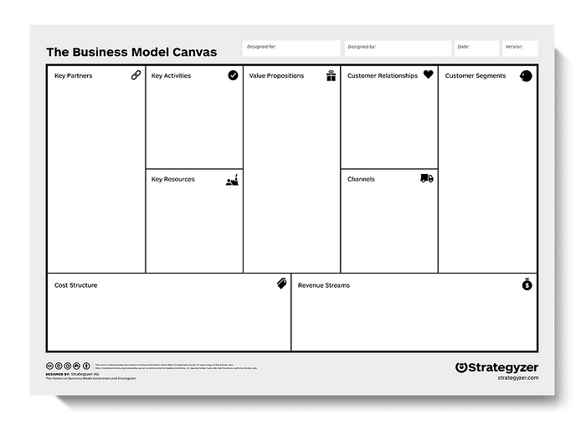

An example of a Business Model Canvas.

The right side of the BMC focuses on the customer (external), while, the left side of the canvas focuses on the business (internal).

Both external and internal factors meet around the value proposition, which is the exchange of value between your business and your customer/clients.

# **Why do we use it?**

* To quickly draw a picture of what the idea entails.
* It allows us to get an understanding of your business and to go through the process of making connections between what your idea is and how to make it into a business.
* It looks at what kinds of customer decisions influence the use of your systems.
* It allows everyone to get a clear idea of what the business will likely be.

# **How to use it**

****Value Proposition:****

The Value Proposition is foundational to any business/product.

It is the fundamental concept of the exchange of value between your business and your customer/clients.

Generally, value is exchanged from a customer for money when a problem is solved or pain is relieved for them by your business.

****Good questions to ask when defining your business/product:****

* What is the problem I am solving?
* Why would someone want to have this problem solved?
* What is the underlying motivator for this problem?

****Tips:****

A good way to approach this for users/customers is by looking at your customer segments and figuring out where your product/service solves the problem for your customer, based on [Maslow’s Hierarchy of Needs](https://en.wikipedia.org/wiki/Maslow's_hierarchy_of_needs" \t "https://medium.com/seed-digital/_blank).

If you are selling your product or service to another business, you are a key partner in them achieving their Value Proposition for their customers.

It is important to have context around the goals the company is trying to achieve for their Customer Segments and where your business/product/service fits in the value chain.

# **Customer Segments**

Customer Segmenting is the practice of dividing a customer base into groups of individuals that are similar in specific ways, such as age, gender, interests and spending habits.

****Things to consider when determining your Customer Segments:****

* Who are we solving the problem for?
* Who are the people that will value my value proposition?
* Are they another business?
* If so, what are the characteristics of those businesses?
* Or, are they other people?
* Does my value proposition appeal to men/women or both?
* Does it appeal to young adults aged 20 to 30 or teenagers?
* What are the characteristics of the people who are looking for my value proposition?

Another thing to gauge and understand is your market size, and how many people there are in the Customer Segment. This will help you understand your market from a micro and macro perspective.

A great place to start understanding your customer is to create customer personas for each of your Customer Segments.

A good place to start understanding your customer is by creating customer personas for each of your customer segments.

# **Customer Relationships**

Okay, so we know our ****Value Proposition**** and have developed ****Personas**** to better understand our Customer Segments or ‘customers’, but what is the relationship we have with our customers?

Customer Relationships is defined as how a business interacts with its customers.

So, do you meet with them in person? Or over the phone? Or is your business predominantly run online so the relationship will be online too?

****Some examples are:****

* In-person (one-to-one)
* Third-party contractors
* Online
* Events (one-to-many)
* Phone

A really helpful step is to create a [User Journey Map](http://theuxreview.co.uk/user-journeys-beginners-guide/" \t "https://medium.com/seed-digital/_blank) of your customers as they interact with your business.

This helps clarify the points of engagement between you and your customer and the modes used to relate to your customers.

This will also help you start to define your operations as a business and also help you identify opportunities for automation.

# **Channels**

Channels are defined as the avenues through which your customer comes into contact with your business and becomes part of your sales cycle.

This is generally covered under the marketing plan for your business.

****Good questions to ask when identifying the channels to reach your customers are:****

* How are we going to tell our ****customer segment**** about our ****value proposition****?
* Where are our customers?
* Are they on social media?
* Are they driving their car and listening to the radio?
* Are they at an event or conference?
* Do they watch TV at 7pm on a Friday night?

****Examples of channels:****

* Social media
* Public speaking
* Electronic mail (email marketing)
* Networking
* SEM (Search Engine Marketing)
* SEO (Search Engine Optimisation)
* Engineering as marketing
* Viral marketing
* Targeting blogs
* Sales and promotions for commissions
* Affiliates
* Existing platforms
* PR
* Unconventional PR
* Social advertising
* Trade shows
* Content marketing
* Community building
* Offline advertising (billboards, TV, radio)

Understanding how to reach your customers is so crucial to your business.

# **Key Activities**

The Key Activities of your business/product are the actions that your business undertakes to achieve the value proposition for your customers.

****Questions to ask:****

* What activities does the business undertake in achieving the value proposition for the customer?
* What is the resource used?
* Time?
* Expertise?
* Distribution of product?
* Technical development?
* Strategy?
* Offer resources (human/physical)?
* What actions does it take you and/or your staff to achieve value exchange?

****Examples:****

* Consulting
* Designing
* Web development
* Baking
* Driving
* Shovelling

# **Key Resources**

Next, you should think about what practical resources are needed to achieve the key activities (actions) of the business.

Key means the resources your business requires to do business.

****These resources are what is needed practically to undertake the actions/activities of your business:****

* Office space
* Computers
* Hosting
* People (staff)
* Internet connection
* Car
* Bike
* Oven
* Electricity
* Car Parts

# **Key Partners**

Key Partners are a list of other external companies/suppliers/parties you may need to achieve your key activities and deliver value to the customer.

This moves into the realm of ‘if my business cannot achieve the value proposition alone, who else do I need to rely on to do it?’.

An example of this is ‘if I sell groceries to customers, I may need a local baker to supply fresh bread to my store’.

They are a key partner to achieve the value my business promises to the customer.

# **Cost Structures**

Your business cost structure is defined as the monetary cost of operating as a business.

* How much does it cost to achieve my business's key activities?
* What is the cost of my key resources and key partnerships?
* How much does it cost to achieve the value proposition for my customers/users?
* Are there additional costs to running a business?
* Legal?
* Insurance?
* What is the cost of my business?
* It is important also to place a monetary value on your time as a cost.
* How much would it cost you to hire you?
* What is the opportunity cost of running your business?

# **Revenue Streams**

Revenue Streams are defined as the way by which your business converts your Value Proposition or solution to the customer’s problem into financial gain.

It is also important to understand pricing your business accordingly to pain of purchase in exchange for the pain of solving the problem for your customer.

But how do you gain revenue?

****There are many different revenue models here:****

* Pay per product (pay per view)
* Fee for service
* Fixed rate
* Subscription
* Dividends
* Referral feeds
* Freemium
* Equity gain

# **An Introduction to Lean Canvas**

As an entrepreneur, one of the most important tasks you can perform is getting your idea(s) out from your head into a tangible format so that you can communicate that with others. In the past, this usually meant a well-researched business plan, that would usually take weeks (more like months) to create.

I turn to the Lean Canvas to help me quickly formulate possible business models, product launches, campaigns and variations of, and communicate this with my stakeholders for my [Lead Flow Method](https://leadflowmethod.com/?utm_source=medium&utm_medium=article&utm_campaign=lean-canvas" \t "https://medium.com/@steve_mullen/_blank) work. Having the Lean Canvas as a visual guide made this part “communicating the model/idea” so much more effective — and I think the most valuable function of the tool.

The problem with business plans for startups & entrepreneurs are that they’re a waste of time, don’t get me wrong a well-researched business plan is important but only at the right stage of your business (usually when you’re in growth/investment).

This quote from Steve Blank sums up this point in case: ***“Business Plan: a document investors make you write, that they don’t read”.***

The key fundamental to Lean methodology is the elimination of waste — this includes time, processes, inventory and more.

So as a lean startup you need a quicker way to get ideas out of your head, you need to stay lean & avoid waste — so, it’s time to introduce Lean Canvas.

Before we jump into the Lean Canvas it’s important to point out that Lean Canvas has been adapted by Ash Maurya from the very popular Business Model Canvas by Alexander Osterwalder — [check out this video for more information](https://www.youtube.com/watch?v=RzkdJiax6Tw" \t "https://medium.com/@steve_mullen/_blank) (40+ mins).

Lean Canvas uses the same 9 blocks concept except they’ve been modified slightly to suit the needs/ purposes/requirements of a Lean Startup. The Lean Canvas is the perfect one-page format for brainstorming possible business models, the blocks guide you through logical steps starting with your customer problems right through to your unfair advantage (often the hardest block to answer).

# **Blank Lean Canvas:**

[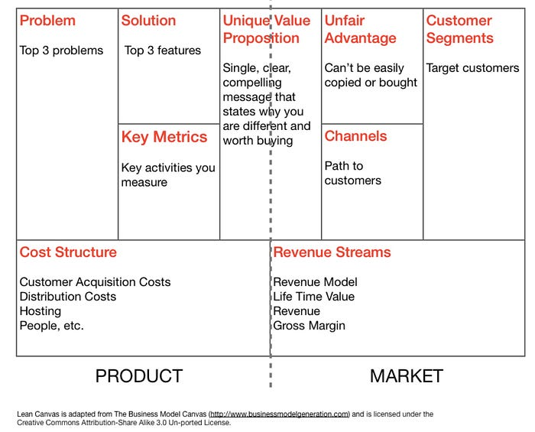](https://leadflowmethod.com/message/introduction-lean-canvas/?utm_source=medium&utm_medium=article&utm_campaign=lean-canvas)